Snowflake to Databricks Migration using Lakebridge (EC2 Setup)
Overview: This document describes the step-by-step process followed to set up and execute Snowflake SQL migration to Databricks using the Lakebridge tool from an EC2 Windows machine.
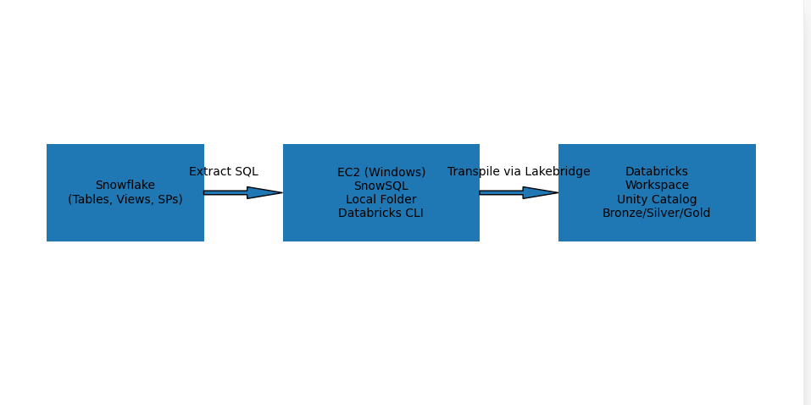
This document describes the step-by-step process followed to set up and execute Snowflake SQL migration to Databricks using the Lakebridge tool from an EC2 Windows machine.
The objective is to:
- Connect to Snowflake
- Extract SQL objects
- Use Databricks Lakebridge for SQL transpilation
- Prepare migrated code in Databricks workspace
2. Environment Details
- Platform: AWS EC2 (Windows Server)
- Source System: Snowflake
- Target System: Databricks
- Tool Used: Databricks CLI + Lakebridge
3. Prerequisites: Before starting, ensure the following:
- EC2 instance is up and running
- Internet connectivity is available
- Access to Snowflake account
- Access to Databricks workspace
- Required permissions for installation and execution
4. Installation Steps
- Install Snowflake CLI (SnowSQL)
Download and install SnowSQL on EC2 machine
snowsql -version
- Confirms SnowSQL is installed correctly
- Ensures CLI is available in system PATH
- Verifies readiness to connect to Snowflake
- Configure Snowflake Connection
snowsql -a OOC47367.us-east-1 -u VENKAT -d LAKEBRIDGE_DEMO -r SYSADMIN -q "SELECT GET_DDL('DATABASE', 'LAKEBRIDGE_DEMO')" -o output_file="C:/Users/Asministrator/Documents/Analyzer/test10.sql" -o output_format=plain -o header=false
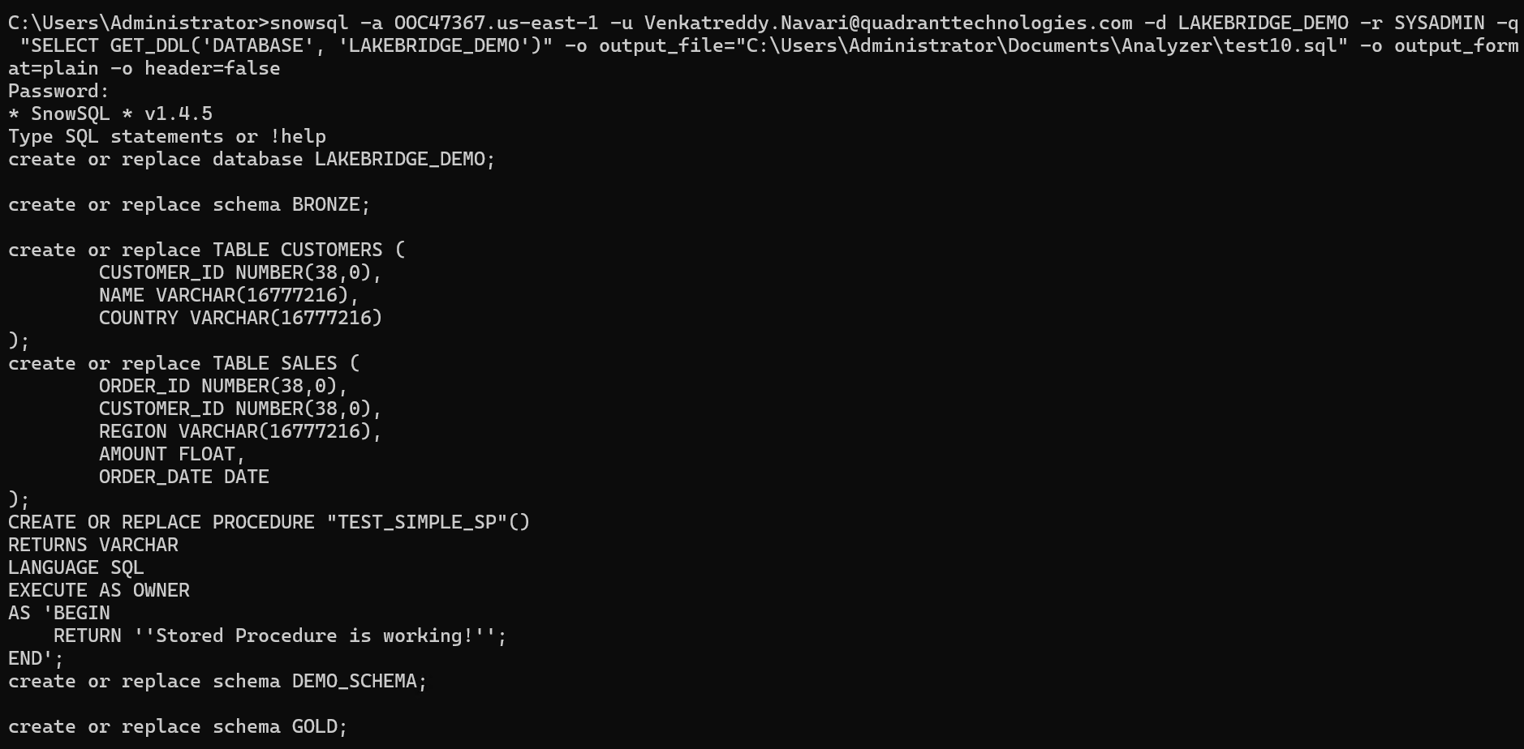
- Establishes connection to Snowflake
- Validates credentials and network connectivity
- Enables access to extract SQL objects
- Create Local Working Directory
C:\Users\Administrator\Documents\Analyzer
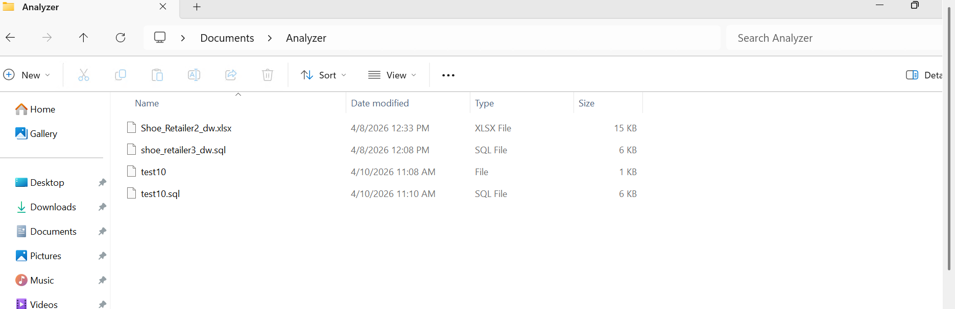
- Stores extracted SQL scripts
- Acts as input source for Lakebridge
- Works as staging area for migration
- Install Databricks CLI
winget search databricks
winget install Databricks.DatabricksCLI
databricks --version
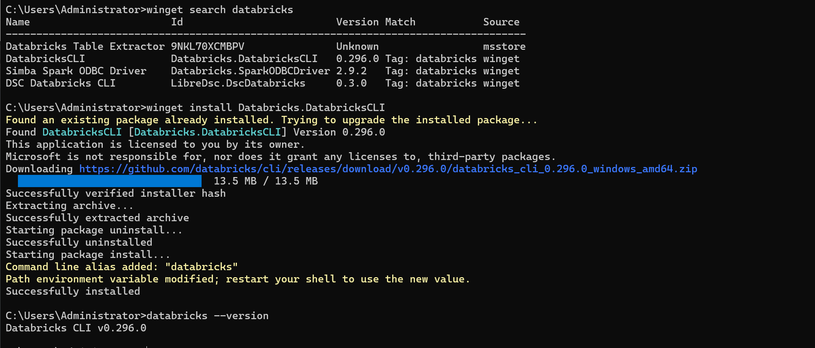
- Installs Databricks CLI
- Required to interact with Databricks workspace
- Mandatory for running Lakebridge commands
- Configure Databricks CLI
databricks configure
- Authenticates EC2 machine with Databricks
- Stores workspace URL and PAT token
- Required before running any Lakebridge commands
- Install Lakebridge Tool
databricks labs install lakebridge
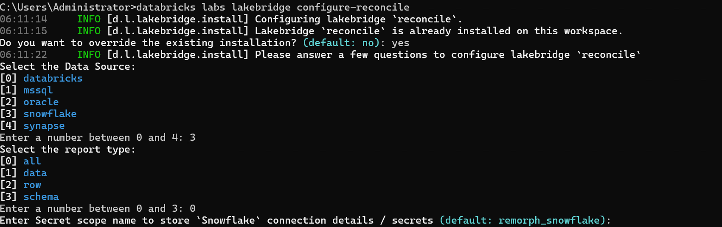
- Installs Lakebridge plugin
- Enables SQL migration and transpilation features
5. Lakebridge Setup and Execution
- Install Transpiler Components
databricks labs lakebridge install-transpile --include-llm-transpiler true
- Installs SQL conversion engine
- Enables LLM-based SQL conversion
- Helps handle complex Snowflake SQL logic
- Execute SQL Transpilation
databricks labs lakebridge llm-transpile \
--accept-terms true \
--source-dialect snowflake \
--input-source C:\Users\Administrator\Documents\Analyzer \
--output-ws-folder /Workspace/Users/venkatreddy.navari@quadranttechnologies.com \
--catalog-name shoe_retailer3_dw \
--schema-name bronze \
--volume migration_test
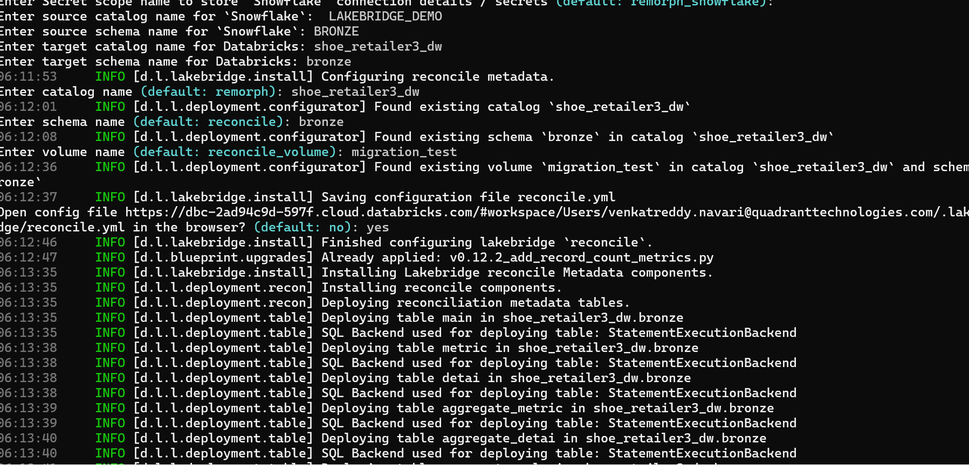
- Converts Snowflake SQL into Databricks SQL
- Uses LLM for intelligent transformation
- Uploads converted SQL into Databricks workspace
- Targets specific catalog and schema
Databricks Execution Verification:
The below screen confirms successful execution of the Lakebridge transpilation process in Databricks, where the target catalog (shoe_retailer3_dw), schema (bronze), and volume (migration_test) are created, and the converted SQL files are stored at /Volumes/shoe_retailer3_dw/bronze/migration_test. It also verifies that the workspace connection is active, the migration pipeline is functioning end-to-end, and the SQL Warehouse is running as expected.

Note: Transpile only converts SQL code (DDL, stored procedures, queries, transformations) from snowflake syntax to Databricks-compatible SQL. It works purely on text/code file hence no connection to Snowflake data is made.
Lakebridge handles code migration, but for the actual data transfer from snowflake to Databricks we need use either of methods.
- Cloud storage staging – Export snowflake tables to S3/ADLS/GCS as parquet/cvs, then load the data into delta lake.
- Databricks Lakeflow connect – Databricks native ingestion connector for snowflake.
- Copy Into/Auto loader – Once files are staged in storage
- Third-party ETL tools – Fivetran, dbt, Airbyte etc

The typical full migration order Analyze -> Transpile(Code) -> Migrate data -> Reconcile.

